Affective Computing 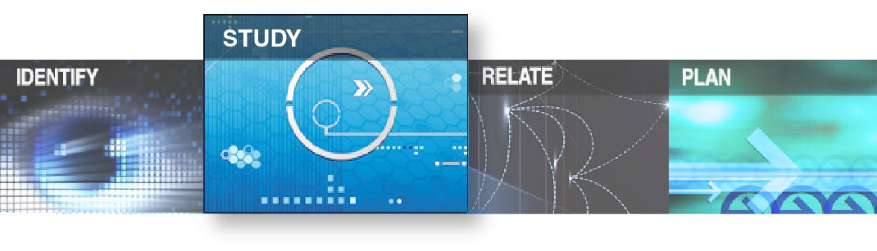– Backgrounder

### Affective computing bridges the gap between human emotions and technology

# Introduction

Affective computing is the study and development of systems and devices that can recognize, interpret, process, and simulate human affects[1]. Affect, in psychology, refers to experiences related to or resulting from feeling, emotion or mood. The technology was first proposed in 1995 by a researcher at MIT (Massachusetts Institute of Technology) to present both theoretical and practical applications of computers that can recognize human emotions[2].

# Affective Computing

Affective computing is an interdisciplinary field spanning computer science, cognitive science and psychology. Using sensors and software, this technology can identify the emotional state of an individual and respond by performing predefined tasks, such as interacting according to a user’s mood or recommending a set of videos to fit the mood of a learner.

One of the motivations behind developing this technology is to provide machines the ability to simulate emotional intelligence, including the ability to simulate empathy. Researchers believe that an intelligent machine should interpret the emotional state of humans and adapt its behaviour accordingly. Thus, the machine should appropriately respond to those emotions to increase the effectiveness and credibility of its responses.

Affective computing is not about building emotional computers in the sense that the computer itself will experience (simulated) emotions, which can imply a loss of desirable rationality. It is also not about building computers that can perform psychological therapy by understanding human emotions. The objective is to build smarter applications by applying the technology to areas such as conversational interfaces e.g. chatbots, computer-assisted learning, human health, biometrics, smart surveillance, fraud detection, marketing, customer service, creative arts and entertainment.

# How it is developed and implemented

This technology is developed and implemented using the following three steps.

1. Capturing specific signals such as cues from facial expressions, body posture, speech and gesture.
2. Processing the signals, mainly using machine learning, to recognize patterns that can help the computer identify emotions specific to the task at hand.
3. Evaluating the identified emotions to decide how to interact with the user and take action.

# Why it is important

Computational technologies are usually objective by design. A typical computer program follows a specific set of rules to analyze data and sometimes takes specific action(s) based on its evaluation of the analysis. This process creates a gap between human emotions and technology due to the subjective nature of emotions. Researchers found that we can bridge this gap by modelling human emotional expression using machine recognition, in other words, using affective computing. This includes invention of new software tools to help people gather, communicate and express emotional information and to better manage and understand the ways emotion impacts health, social interaction, learning, memory and behaviour[3].

# Applications

MIT Media Lab is one of the pioneers in researching and developing affective computing technologies. Currently, there are many companies, including technology giants like Microsoft, who are building affective computing solutions for customers. Below are some of the applications of this technology.

* Using voice-based emotion recognition, companies are tracking customer satisfaction. They are using this to make real-time adjustments to their processes or offer real-time guidance to their personnel. This can be applied to chatbots so that they can craft more intelligent responses guided by users’ emotions.
* Monitoring students in classroom or online to assess their interest and attention[4]
* Using facial, gesture and body language recognition to identify potential criminals, such as terrorists in public gatherings[5]
* Trying to better manage and understand the ways emotion impacts health, social interaction, learning, memory, and behaviour.
* Finding new ways to forecast and prevent depression.
* Inventing ways to help people with special needs who face communication, motivation and emotion regulation challenges.
* Monitoring emotional state of drivers as they are driving, to ensure road safety.

# Ethical implications and AI safety

Emotion is subjective. While many emotions such as happiness, sadness, anger, disgust, fear and surprise are universally common, their representations can vary from person to person or from culture to culture[6]. This creates ethical issues when it comes to developing computer programs to detect certain emotions, especially when these programs are designed to take actions based on the emotions they identify. Since these programs use machine learning algorithms, algorithmic bias due to lack of adequate training data as well as the lack of cultural diversification in the datasets become an ethical challenge in justifying the accuracy of the affect recognition process. This imposes further issues when these systems are put in place to perform criminal surveillance or detect fraudulent behaviours in people.

There are ongoing works in research labs and companies around the world to gather more diverse training data and quantify a model’s uncertainty in perceiving complex emotions[7]. More research is being done on ensuring AI safety by allowing AI models to learn about implicit cues from social interactions of humans[8].

# Future of affective computing

Affective computing is already being used in conversational AI[9] systems such as chatbots by providing them the ability to detect a wide variety of human emotions while interacting with users[10]. The global affective computing market size is projected to grow from USD 22.2 billion in 2019 to USD 90.0 billion by 2024[11]. The major factors driving the market include the growing demand for voice-enabled virtual assistants, soaring need to counter fraudulent activities and enhanced security in the automotive and banking sectors. It is also being predicted that other sectors, such as healthcare and education will benefit from the integration of affective computing technology.

Related Topics: Artificial Intelligence, Language-based AI, Personalized Focused AI, Deep Learning, AI Ethics, Biometrics

1. What is affective computing? - Prof. Ahmed Banafa, Published on June 6, 2016. <https://www.bbvaopenmind.com/en/technology/digital-world/what-is-affective-computing>
2. Affective Computing, R. W. Picard . Published in 1997. https://vismod.media.mit.edu/pub/tech-reports/TR-321.pdf
3. Affective Computing, MIT Media Lab. Retrieved on April 3, 2020, from: <https://www.media.mit.edu/groups/affective-computing/overview/>
4. Does Emotive Computing Belong in the Classroom? - Ron Spreeuwenberg. Published on January 4, 2017. <https://www.edsurge.com/news/2017-01-04-does-emotive-computing-belong-in-the-classroom>
5. Terrorist classifier. Retrieved on April 16, 2020, from: <https://www.faception.com/our-technology>
6. Don’t look now: Why ... emotions. - Oscar Schwartz. Published on March 6, 2019. <https://www.theguardian.com/technology/2019/mar/06/facial-recognition-software-emotional-science>
7. Modelling uncertainty in deep learning for inherently subjective tasks. Retrieved on April 3, 2020, from: <https://www.media.mit.edu/projects/uncnet/overview/>
8. Learning via Social Awareness. Retrieved on April 3, 2020, from: <https://www.media.mit.edu/projects/learning-via-social-awareness-improving-sketch-representations-with-facial-feedback/overview/>
9. AI: Artificial Intelligence
10. When Machines Know How You're Feeling. - Bernard Marr. Published on January 25, 2017. <https://www.forbes.com/sites/bernardmarr/2017/01/25/when-machines-know-how-youre-feeling-the-rise-of-affective-computing>
11. Affective Computing Market. Published by Markets and Markets, on November 2019. <https://www.marketsandmarkets.com/PressReleases/affective-computing.asp>